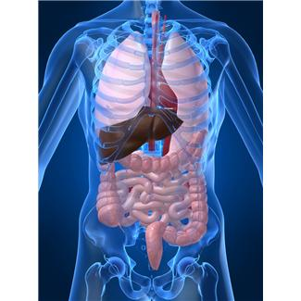
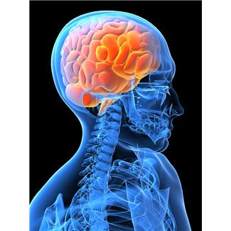
HUMAN ANATOMY AND
PHYSIOLOGY
MR. GARCIA
COURSE SYLLABUS

Contact: (714) 241 – 6410 ext: 66500
Email: reuben.garcia@sausd.us

Description: Anatomy and physiology is a one year course that involves the structure and function of the human body, as it pertains to how the body systems relate to one another in organization, adaptation, and homeostasis. This course will involve laboratory activities, projects, dissections, textbook material, models, diagrams, journal writings, and clinical studies. The material learned in this course can be applied to medical field careers, health and fitness careers, and biological research careers.

Expected Schoolwide Learning Results:
Valley High School graduates will be:
- Effective Communicators
- Critical Thinkers
- Self Directed Learners
- Responsible Community Members

Materials: Essentials of Anatomy & Physiology (textbook), notebook, laboratory notebook, pencil, pen, college-ruled paper, drawing paper, graph paper, colored pencils or markers, glue stick, ruler, scissors, and index cards (3 x 5).

Classroom Websites: You may access these classroom websites at the following
addresses:
www.sausd.us/valley
classroom.google.com

You may use these websites to get the weekly schedule, syllabus, powerpoints, lab directions, handouts, assignments, and additional science websites.

Your purpose for being in school is to learn. Any behavior that disrupts the learning process for you or your classmates will not be tolerated. The following behavior rules will be followed:
A. Behavior
1. When the tardy bell rings, be in your assigned seat, quiet, and ready to
work.
2. Bring a pencil or pen, paper, and textbook to class everyday.
3. Go to the restroom and drink water during the passing time.
4. No cell phones, mp3's, iPod's, and cameras to be used in our classroom.
5. No eating, chewing gum, chewing candy or drinking in class and no litter
in our classroom.
6. No cheating on tests, quizzes, or assignments.
7. No profanity.
8. Always cooperate and respect the right of others.

B. Discipline Plan
Rewards for following rules:
1. Verbal and/or Written Praise.
2. Given Extra Credit.
3. Receive Token Awards.
4. Receive Outstanding Citizenship.

Consequences for not following rules:
1. 1st Offense = Verbal Warning (Redirect)
2. 2nd Offense = Teacher Conference and/or Seat Change
3. 3rd Offense = Phone Call Home
4. 4th Offense = Office Referral and Parent Conference

C. Grades
There are 6 ways to earn points toward one grade in this science class.

1. Human Anatomy and Physiology Notebook: You are responsible for completing
each assignment on time. I will stamp each completed assignment and grade each
assignment. All assignments are to be kept together, in order, and to be placed neatly in
a classroom notebook and turned in at the end of each semester. If the notebook is late
due to an excused absence, it must be stated on the classroom notebook rubric where it
can be seen. I will not accept a late unexcused classroom notebook.

2. Group Lab Projects: At times, you will work with others in a group or with a partner
doing lab activities and projects. Everyone within the group is required to participate.
I will give points for individual and group participation. You are also required to use a
lab notebook for recording laboratory activities.

3. Quizzes: You are responsible for knowing the vocabulary and science topics from
each chapter in the textbook.

4. Chapter Tests: At the end of each chapter, you will be tested over material covered in
the chapter. The test involves multiple choice, fill-in-the-blank, matching, short
answers, and essay questions.

5. Citizenship: Good behavior and cooperation are important for learning. That is why
citizenship makes up a percentage of your grade.

6. Extra Credit: There will be moments where I will give you bonus points and tokens
for good behavior, class participation, extra assignments, and excellent work.
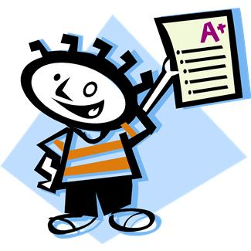
D. Grading Scale
90% - 100% = A
80% - 89% = B
70% - 79% = C
60% - 69% = D
0% - 59% = F

E. Absences:
You Must bring in a re-admit slip, excused or not. You are responsible for making up
any work that you missed. If you are absent on the day an assignment is due, you
must turn it in on the day that you return.
F. Cheating:
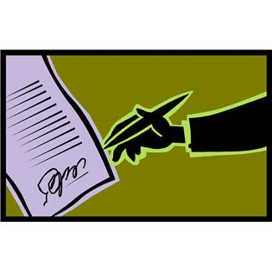
It is your job to convince me that you are not cheating. Ways to convince me:
1. Keep Your Eyes On Your Own Paper.
2. Keep Your Answer Sheet Covered.
Plagiarism will not be tolerated.

I have read the class description and class requirements with my son/daughter.

Parent/Guardian Signature: _____________________________ Date: ____________

Student Signature: _____________________________________ Date: ____________

